**DAILY ONLINE ACTIVITIES SUMMARY**

|  |  |  |  |  |  |  |  |  |
| --- | --- | --- | --- | --- | --- | --- | --- | --- |
| **Date:** | **22-06-2020** | | | | | **Name:** | **Deril Quadras** | |
| **Sem & Sec** | **8 A** | | | | | **USN:** | **4AL16CS031** | |
| **Online Test Summary** | | | | | | | | |
| **Subject** | | **SMS** | | | | | | |
| **Max. Marks** | | **60** | | **Score** | | | **Mail not received.** | |
| **Certification Course Summary** | | | | | | | | |
| **Course** | **Introduction to Amazon Certificate Manager Private Certificate Manager.** | | | | | | | |
| **Certificate Provider** | | | **AWS** | | **Duration** | | | **15 mins** |
| **Coding Challenges** | | | | | | | | |
| **Problem Statement:**   1. **Write a C Program check a string is palindrome or not.** | | | | | | | | |
| **Status: Solved** | | | | | | | | |
| **Uploaded the report in Github** | | | | | **Yes** | | | |
| **If yes Repository name** | | | | | **Derilquadras/online_c_coding_repository** | | | |
| **Uploaded the report in slack** | | | | | **Yes** | | | |

Online Test Details:

Mail not received.

Certification Course Details:

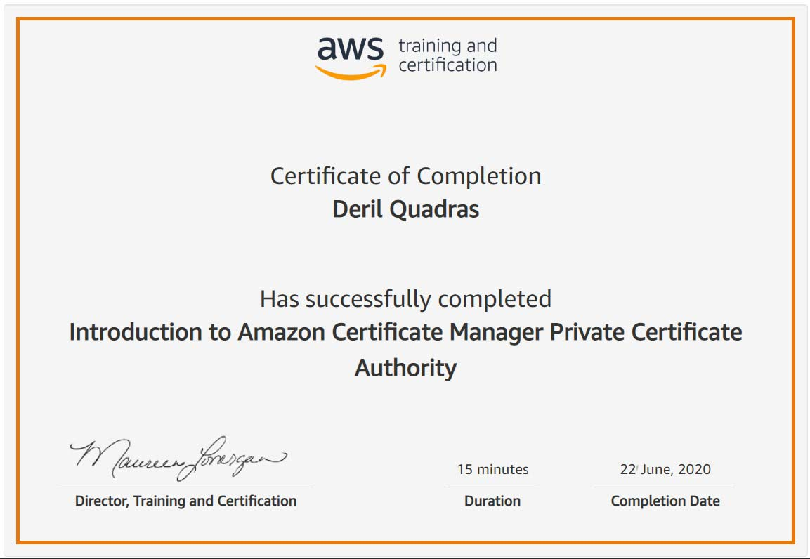

Coding Challenges Details:

**PROGRAM 1 .**

**//Palindrome**

**#include <stdio.h>**

**#include <string.h>**

**int main()**

**{**

**char str[25], a[25] = {'\0'};**

**int i, len= 0, flag = 0;**

**printf("Enter a string \n");**

**gets(str);**

**puts(str);**

**for (i = 0; str[i] != '\0'; i++)**

**{**

**len++;**

**}**

**for (i = len - 1; i >= 0 ; i--)**

**{**

**a[len - i - 1] = str[i];**

**}**

**for (flag = 1, i = 0; i < len; i++)**

**{**

**if (a[i] != str[i])**

**flag = 0;**

**}**

**if (flag == 1)**

**printf ("%s is a palindrome \n", str);**

**else**

**printf("%s is not a palindrome \n", str);**

**}**